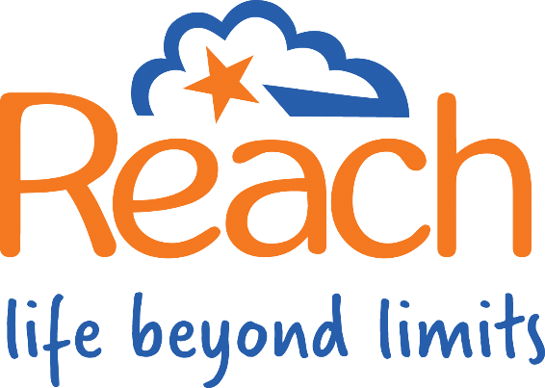

Job Title: 18-25 Retreat & Mentoring Programme Coordinator
Reporting to: Reach Charity Lead
Organisation: Reach Charity Ltd
£30,950 pro-rata / Remote / Fixed term contract (3 years) / 1 day a week (7 hours)
About REACH:
Reach Charity Ltd empowers individuals with Upper Limb Difference through support, advocacy, and community. We believe in the power of peer support and strive to create inclusive and empowering experiences for our members.
About the Role:
We are seeking an enthusiastic individual with lived experience (individual, parent/carer, relative or friend) of Upper Limb Difference to join our team as the 18-25 Retreat & Mentorship Programme Coordinator. This exciting new role will play a vital part in delivering a transformative experience for our young adult members. You will be a key figure in creating a supportive and inspiring environment where young people can connect, grow, and thrive. In this role you will be working from home, the role involves some travel to project and charity events and meetings, Reach charity will cover your expenses.
Key Responsibilities:
- Retreat Planning & Delivery:
  - Scope and book low-cost retreat locations, ensuring accessibility and inclusivity.
  - Collaborate with mentors to develop engaging and inclusive retreat activity programmes.
  - Integrate physical activities that promote wellbeing, considering the diverse needs and abilities of participants.
  - Conduct thorough risk assessments for all retreat activities and participant participation.

- Mentorship Support:
  - Coordinate the annual delivery of safeguarding and mental health first aid training for all mentors.
  - Source and facilitate further training opportunities for mentors who wish to expand their skills and knowledge.
  - Provide ongoing support and guidance to mentors, addressing any challenges or concerns.
- Programme Management:
  - Manage the budget for the retreat and mentoring programme.
  - Coordinate the participation of 18-25 participants and mentors in Durham University's research project.
- Recruitment & Outreach:
  - Collaborate with the Reaching Out Project Manager (STF) and the Reach Team to promote the programme and recruit 18-25 members.
- Evaluation & Development:
  - Gather feedback from participants and mentors to continuously improve the programme.
  - Contribute to the ongoing evaluation and development of the Retreat & Mentorship programme, considering different leadership and facilitation models.
  - Support Project participants to generate income to sustain the 18-25 Programme after VTCT funding ends in February 2028.

Essential Skills & Experience:
- Lived experience of Upper Limb Difference.
- Excellent organisational and planning skills.
- Strong communication and interpersonal skills.
- Ability to work independently and as part of a team.
- Passion for supporting young people with Upper Limb Difference.
- Budget management experience.
- Experience in risk assessment and safeguarding.
- Experience working with Office 365, Word, Excel, Teams, SharePoint and Outlook.
Desirable Skills & Experience:
- Experience in project management.
- Experience in delivering training or workshops.
- Experience in peer support or mentoring.
- Knowledge of inclusive practices and accessibility.
- Experience in event planning, experience using project planning tools i.e. MS Project Planner.
- Experience of community fundraising, including events, and Trust & Foundation fundraising.
- Full clean driving license
Benefits:
- Opportunity to make a real difference in the lives of young people.
- Be part of a supportive and passionate team.
- Opportunities for professional development.
- Flexible working arrangements considered.
To Apply:
Please submit your CV and a covering letter outlining your suitability for the role to Ashley Blackburn, Reach Business Support Email: ashleyb@reach.org.uk
NB: Please make sure to respond to each section within the JD & PS as we will be considering your application against each point.
If you would like a conversation about the role please contact SJ, Charity Lead, M: 07932 747 652.
Closing Date: Midnight, 26 March, 2025
Interviews: Monday 31 March & Friday 04 April
REACH is an equal opportunities employer and welcomes applications from all sections of the community.
Note: This is a new project and a new role. This job description is intended to provide a general overview of the position. It is not exhaustive and may be subject to change.

